PATIENT INFORMATION SHEET
MAGNETIC RESONANCE IMAGING – ULTRASOUND (MRI-US) FUSION TRANSPERINEAL TARGETED PROSTATE BIOPSY

Manchester Urology offers Transperineal Magnetic Resonance –Ultrasound (MR-US) Fusion Targeted Prostate Biopsies often in combination with Transperineal Template Prostate Biopsies. Both of these procedures are performed in collaboration with Nuada Medical.
The Transperineal approach has been proven to have a much lower risk of infection and sepsis. Transperineal MR – US Fusion Targeted Prostate Biopsies provide a diagnostic process which is far more precise and accurate than traditional Transrectal Ultrasound Guided Biopsies (TRUS) biopsies which are currently performed in both the public and private healthcare systems elsewhere in the world.
MR-US Fusion involves a multidisciplinary approach with a combination of the latest 3 Tesla MRI imaging techniques and then preparation of a map of the prostate with identification and outlining of any abnormal areas by a Consultant Radiologist. This produces a very precise and accurate outline for the Manchester Urology Surgeon. In theatre the live dynamic ultrasound machine is then fused with the previously prepared MR images to allow the surgeon to identify the specific abnormal areas. Using the transperineal approach, the template is applied so that specific areas can be targeted with precision. This also allows us to record exactly where we have biopsied and ensure we have targeted the abnormal areas sufficiently (Figure 1 and 2)
Figure 1
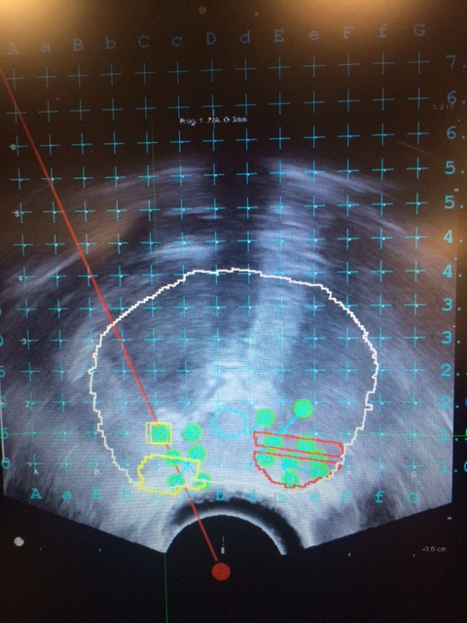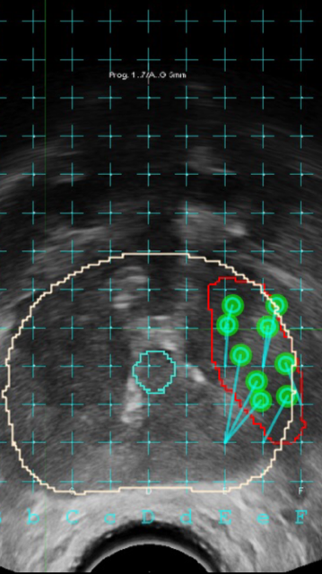
Figure 2
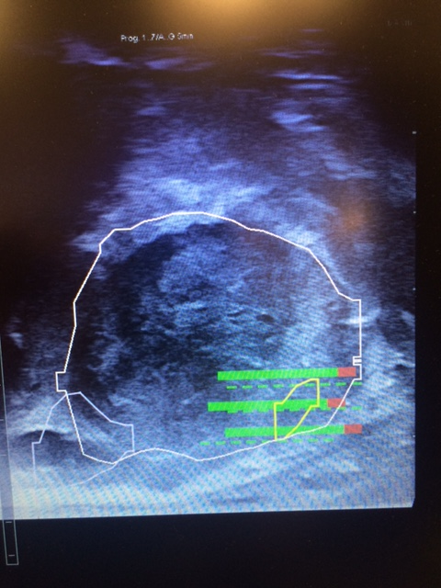

This precise and accurate prostate cancer diagnostic procedure is performed by the Surgeons at Manchester Urology in collaboration with the London based, Nuada Medical who provide the equipment, radiological and technical support. From a patient perspective this collaboration ensures that the MR Scan and biopsies are performed locally while still using the latest technology available in prostate cancer diagnosis.
WHAT IS INVOLVED IN A MRI-US FUSION TRANSPERINEAL TARGETED PROSTATE BIOPSY?

Patients seen with either a raised PSA blood test or an abnormal feeling prostate will undergo a 3T Multiparametric MRI. This MRI scan will then be used to develop a contoured map of your prostate with any abnormal areas superimposed. This latest technology allows the Manchester Urology Surgeon to then link these MRI Images to the live dynamic ultrasound machine in theatre.
The MRI –US Fusion biopsy is carried out under general anaesthetic. This is normally a daycase procedure but some patients may need to stay for 1 night.
5 days before the biopsy you will need to start a tablet called Tamsulosin to minimise the risk of retention of urine (You will need to continue this for 2 weeks post procedure as well).
Prior to the procedure you will be seen in the clinic by your surgeon. He will answer any questions you may have. You will be asked to sign a consent form to state that you agree to have the procedure if you have not already done so. On tohe day of surgery you will be assessed by a Consultant Anaesthetist who will discuss the anaesthesia.
Once you are under the anaesthetic a plastic tube called a catheter is inserted through the penis into the bladder so that the water passage can be seen properly throughout the procedure and avoided. After the biopsies have been taken, the catheter is removed. The catheter is also used as a marker to aid the fusion process.
The procedure lasts for 30 to 45 minutes and involves taking biopsies through the skin that lies in front of your back passage rather than through the back passage. An oral antibiotic is given 1 hour before the procedure and an intravenous antibiotic is given at the start of the procedure. A thick padding will be placed over the area of skin that the needle has gone through to prevent a lot of bruising. This padding should be left for at least 6 hours.

How are prostate MRI –US Fusion biopsies carried out?

Once the catheter has been inserted an ultrasound probe is inserted into the back passage and the prostate is scanned. The images from the MRI map and the dynamic ultrasound images are then fused. This then allows the surgeon to specifically target any previously identified abnormal areas on the MRI via the Transperineal approach. Using a grid with holes placed every 5mm, a biopsy needle is inserted through an individual hole in the grid, then the skin, before then being guided to a specific area of the prostate and a biopsy taken. The number of biopsies will depend on several variables including size of the prostate and also size and number of abnormal areas. Each section biopsied is placed in a separate pot for a Consultant Histopathologist to examine under the microscope. A report is given for each area telling us whether each biopsy has cancer in it or not. Other information is also given such as whether the tissue looked inflamed or whether there are other features such as precancerous areas in the prostate.

What are the potential side effects of MRI-US Transperineal Fusion biopsies?

Transperineal biopsies have a much lower risk of infection and sepsis compared with traditional trans rectal biopsies.

Complications include:
- bruising of skin in all men and occasionally bruising that spreads to the scrotum
- prostatitis (inflammation or infection of the prostate) in some men
- temporary discomfort or pain in the back passage area (most men)
- bloody urine for the first few hours to a maximum of 2 days in most men
- bloody semen in most men lasting for up to 3 months in a few men
- retention of urine requiring a temporary catheter (2-10 in 100)
- infection (requiring admission and intravenous antibiotics, 0-1 in 100)
- a few men have experienced temporary poorer erections

What happens after the procedure?
You can go home the day of the procedure once you have passed urine.
You may experience some perineal pain or discomfort after the procedure but paracetamol or other simple pain killers should be adequate. You should avoid any medication containing aspirin for 24 hours as it causes blood thinning and will therefore increase the risk of bleeding. You can expect to see some blood in your urine for 1 - 2 days following the biopsies. You may notice some blood in your semen for up to 3 months. If the bleeding becomes excessive, prolonged or if you start to pass blood clots then you should seek medical attention. In up to 10% of patients, swelling may occur in the prostate gland as an inflammatory response to the biopsies being taken. This can cause difficulty in passing urine and may stop you passing urine completely. This is known as urinary retention and you would then need a catheter inserted to drain your bladder for a few days. You will not be allowed to go home until you have passed urine. There is a <1% risk of developing sepsis (a very bad infection) following prostate biopsy. The antibiotics you will be given before and during the procedure should help prevent this. If you develop flu-like symptoms within 24 hours of the biopsies being taken (fever, cold shivers, general aching) you should seek medical assistance immediately. You should drink plenty of fluids.
You will be given contact numbers which you can call at any time should you have a problem.

When will the results be available?
You will be seen in the clinic in approximately 7 -10 days after the procedure with your results. The reports will indicate where the cancer is, how much cancer and how aggressive it is by denoting the Gleason score of each focus and also tell you how many biopsies were positive in each location.

